**ASSIGNMENT 3**

1. Difference between DDL and DML:

DDL is data definition language whereas DML is data manipulate language. It shows that DDL is used to create the data structure, while DML is used to work with the data that was defined by DDL.

1. DDL commands: create (table, database), drop, alter and etc.
2. DML commands: select, insert, update, delete and etc.
3. Create Tables by writing SQL statement

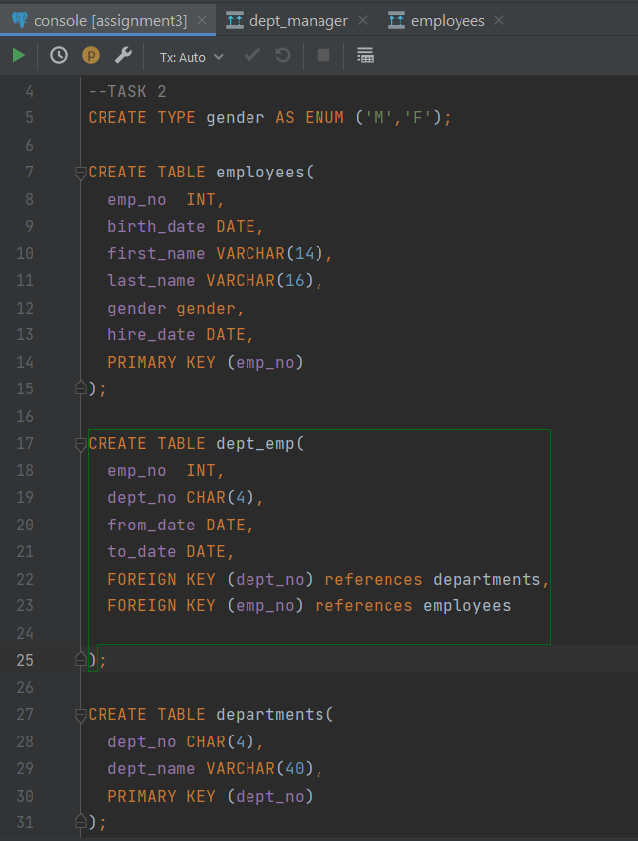 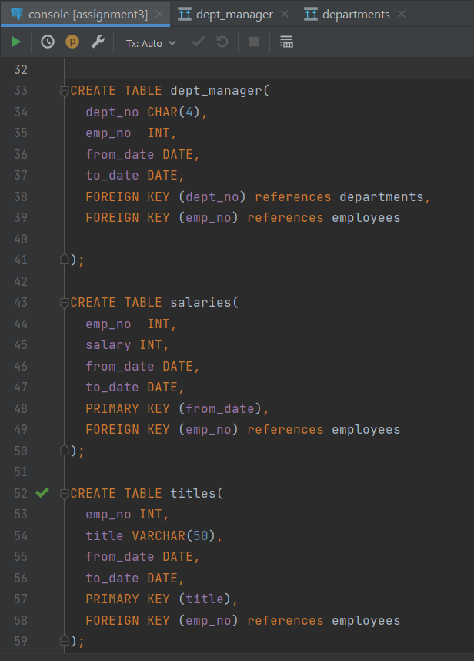

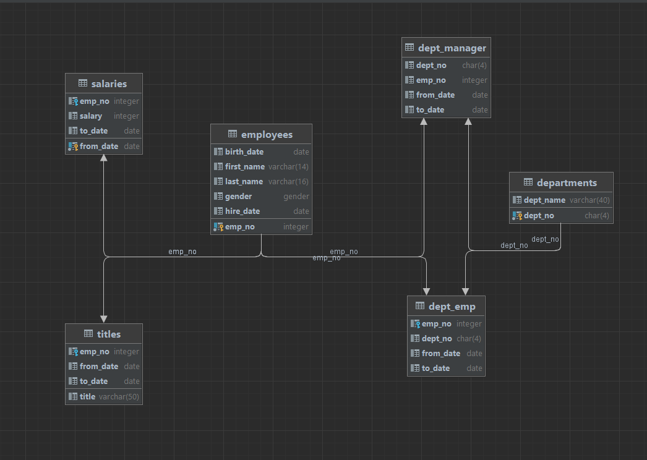

1. Write SQL statements describing tables

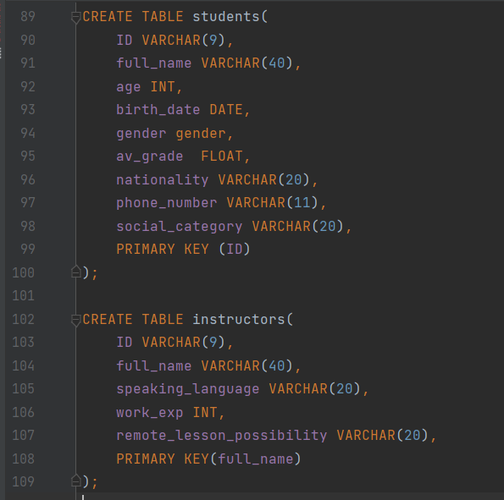 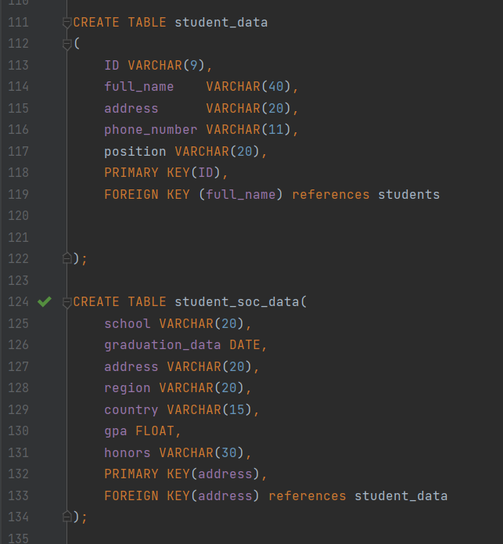

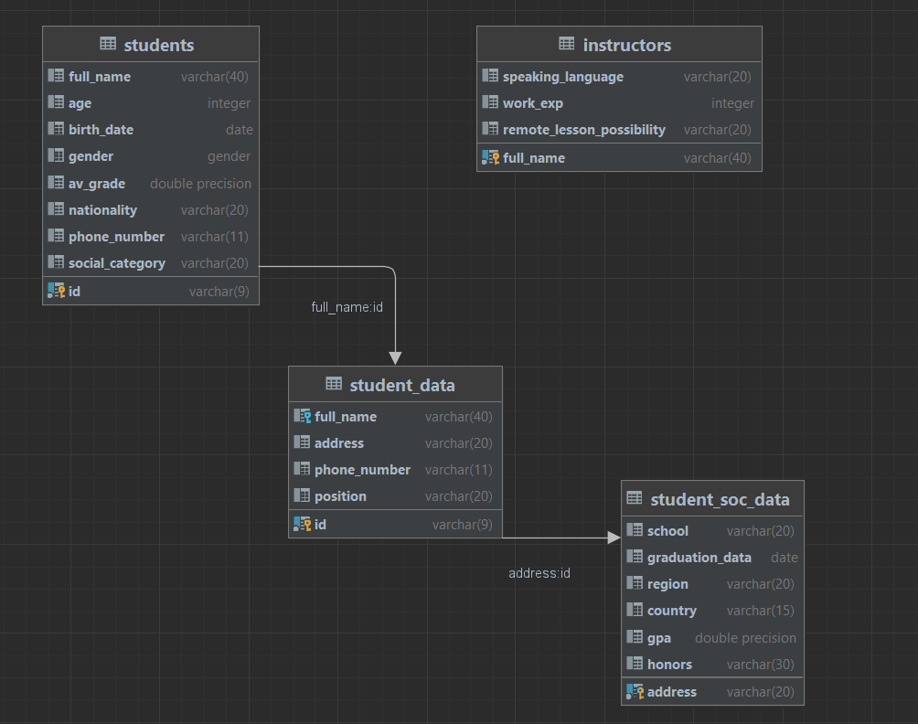

1. Give examples of insertion, update and deletion of data on tables from exercise 2.
2. **INSERT**

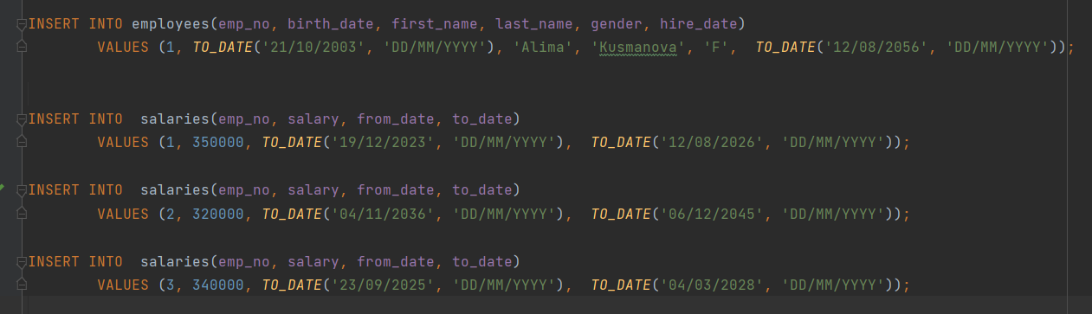

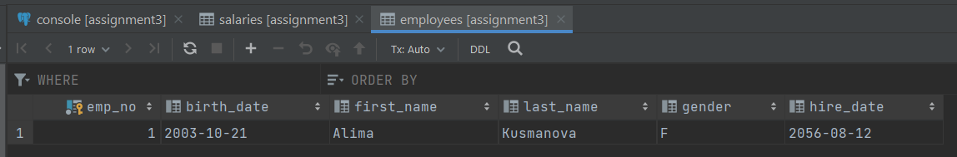

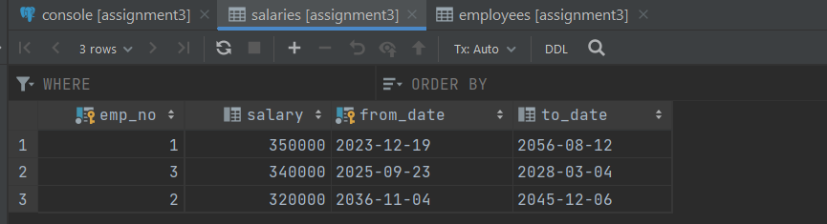

1. **UPDATE**

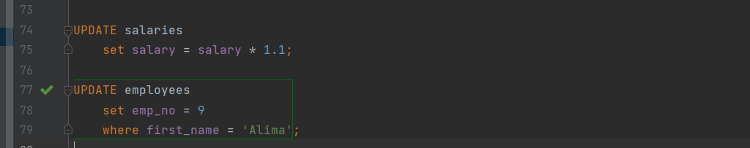

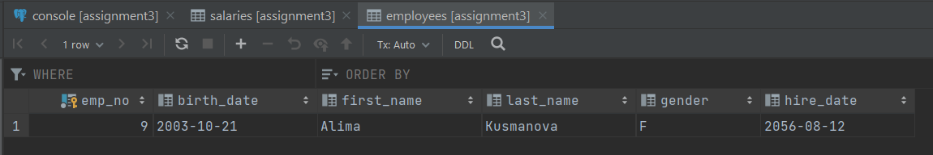

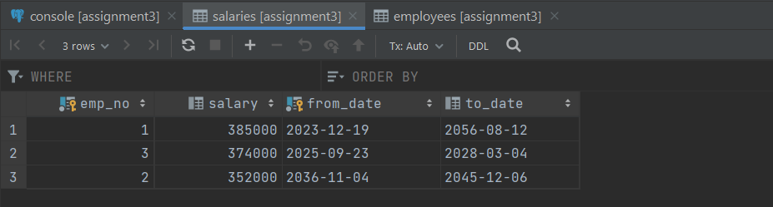

1. **DELETE**



